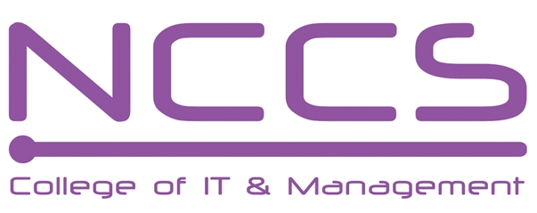
National College of Computer Studies
(NCCS-College of IT & Management)

Final Examination (2021)
BSc.CSIT/First Semester/ CSC – 110 : C Programming

Candidates are required to answer the questions in their own words as far as practicable.

Full Marks: 60
Pass Marks: 30
Time: 3 Hours
Set A

Attempt any Two Questions. [2×10=20]
- What is loop? Explain do while loop with suitable example. Compare do while loop with while loop. Write a program to find sum of square of first N natural number using while loop. [1+3+2+4]
- What is structure? Differentiate structure with union? Design a structure student with data members roll, name, and percentage. Write a main program in C to read detail of 20students and display detail of students with percentage between 50 and 70. [1+2+7]
- Why data file is needed? Explain different file opening modes.Write a program to copy a text file. [2+2+6]

Attempt any Eight Questions. [8×5=40]
- Explain flowchart with suitable example. List example of using flowchart. [3+2=5]
- What is operator? List the different types of operator based on utilities. Explain the logical operator with truth table and example. [1+1+3]
- Explain if else if statement with syntax and semantic? How it can used in decision making? Explain with example. [2+3]
- What is pointer? Explain relationship of pointer and 1D array. [1+4=5]
- How 1D array can be initialized? Explain with suitable example.Write a program to find of sum and average of {12,34,65,100,43,68}. [1+4=5]
- Explain function call by value and function call by reference with suitable example. [2+3=5]
- What is data types? Explain the basic data types with example. [5]
- List any six graphics with its use.Write a program to draw circle using arc() function. [1+4=5]
- What do you mean by unformatted I/O function? Explain with examples. [5]

********
Note: Please send your answer sheet to the following e-mail address.
To: csit10batch@nccs.edu.np
CC: dinesh.khadka@gmail.com

